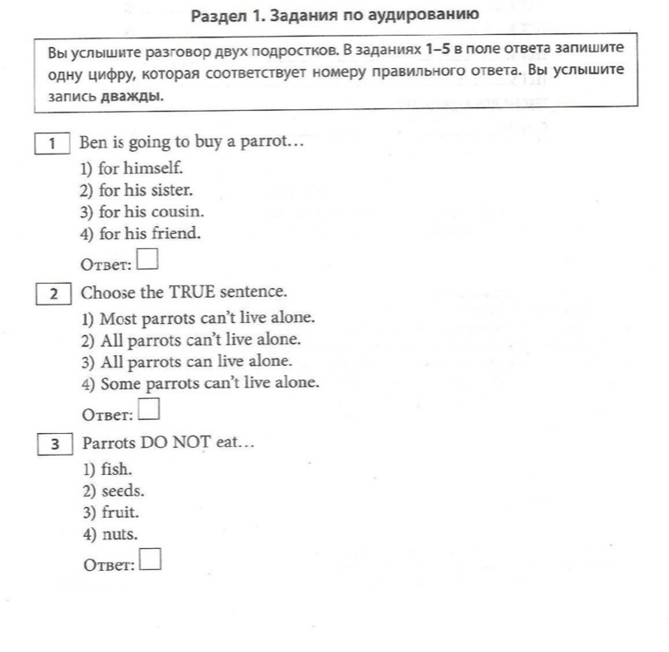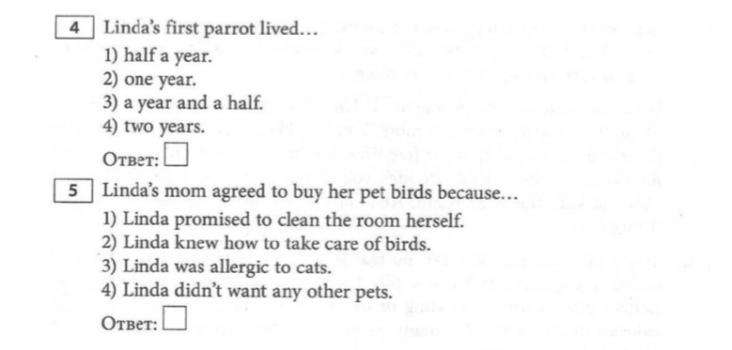

Раздел 2. Задания по чтению
Задание 2
Прочитайте текст.

My Mother’s Birthday

My name is Kate. My family is a typical Russian family. There are four of us. I have got a mother. Her name is Ann. She is a teacher. She is very kind. Her hobbies are singing and shopping. My mother is fond of reading detective stories.
My father`s name is Peter. He is a driver. He is clever and sporty. My father is fond of fishing. My brother Nick is small. He is only four. He likes playing with his toys.
We are a close and friendly family. We like to spend time and holidays together.
Tomorrow it will be my mother’s birthday. My brother and I will go shopping together with our father. We are going to buy our mum a birthday present. It will be a nice scarf. She would like to have a white one. And we shall buy flowers for her, too.
Tomorrow my brother and I will clean the flat. We won’t be lazy. Father will help us. Then we’ll make our kitchen clean and bright. Tomorrow we will lay the table. We would like our mother to be happy.

Установите соответствие утверждений 1-8 содержанию текста. Отметьте каждое утверждение TRUE, если оно соответствует содержанию текста, FALSE, если оно не соответствует.

- There are five people in Kate’s family.
- Kate’s father is clever.
- Kate’s brother is four.
- Tomorrow it will be Kate’s birthday.
- Kate’s mother will get a red scarf for her birthday.
- Tomorrow Kate and her brother will clean the flat.
- Kate and her brother won’t be lazy tomorrow.
- Tomorrow the family will lay the table.
Раздел 3. Задания по лексике и грамматике
Задание 3
Выберите правильный вариант ответа.
1.It is .......... orange.
A. an B. a C. -
2. The children .......... at the conema
A. is B. have C. are
3. My mum is an actress. .......... films are great!
A She B. Her C. Your
4. There .......... a park near my house.
A. are B. is C. aren’t
5. Lisa and Betty .......... got a big house.
A. have got B. has C. have
6. Danny lives on the .......... floor.
A. one B first C.nine
7. The table is .......... of the sofa.
A. in front B. next C. near
8. .......... you German ?
A. Is B. Are C. Am
9. Lara is .......... home today.
A. in B. at C. on
10. .......... your new flat?
A. Does Dan like B. Is Dan liking C. Like Dan

Задание 4.
Соотнесите предложения с переводом.
1. . В коллекции моего отца есть много книг.
2. В школе мы изучаем два иностранных языка: французский и английский.
3.Мой брат любит играть со своими игрушками.
4. В Орле много красивых зданий и исторических памятников.
5. Я люблю смотреть сериалы по вечерам.
A. There are many beautiful buildings and historical monuments in Orel.
B. My brother likes to play with his toys.
C. I like to watch TV shows in the evenings.
D. There are many books in my father's collection.
E. At school we study two foreign languages: French and English.

1 | 2 | 3 | 4 | 5

