РАЗДЕЛ 1. АУДИРОВАНИЕ
- Послушай и обведи парильный вариант ( - нравится, - не нравится).
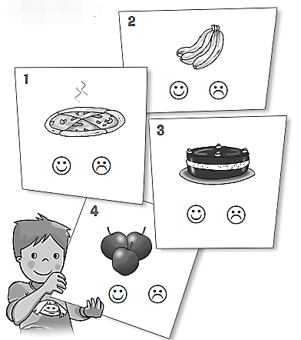

РАЗДЕЛ 2. ЧТЕНИЕ
- Прочитай текст и заполни пропуски в предложениях.
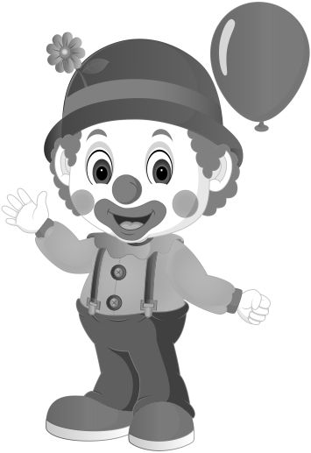
Clancy the Clown
Clancy the clown is a funny boy. His name is Robert. He likes to make children laugh. He wears big shoes, blue shirt and jeans. He wears a lot of makeup so his eyes look big. He also has a big red nose.
- Clancy the clown is a __________________________________.
- His ________________________ is Robert.
- He likes to make _____________________________ laugh.
- He wears _____________ shoes, _____________ shirt and jeans.
- He also has a _______________________________ nose.

РАЗДЕЛ 3. ЛЕКСИКА
- Соедини английские слова и их перевод.

- garden | ________ | - полка
- apples | ________ | - глаза
- frog | ________ | - лягушка
- shelf | ________ | - сад
- eyes | ________ | - яблоки

- Подбери верные подписи к картинкам.
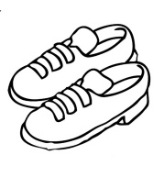 |  | 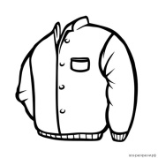 |  | 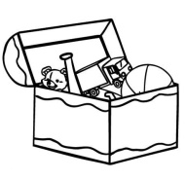
- skirt  - shoes |  | - jacket  - hat |  | - toy box  - toy soldier
 | 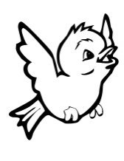 |  | 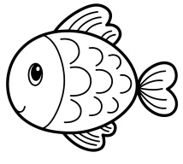
 | - dolphin  - bird |  | - fish  - chimp

- Найди и зачеркни лишнее слово в каждом ряду.
- jump, swim, run, shoes.
- mouth, ears, bird, eyes.
- fish, cake, horse, frog.
- milk, ice cream, apples, boy.
- mummy, happy, daddy, grandma.
- skirt, one, seven, ten.

- Замени подчеркнутые слова местоимениями he, she, it . Выбери и обведи нужную букву.
- Mummy is in the kitchen. | - he | - she | - it
2) Larry is in the circus. | - he | - she | - it
3) Grandpa is in the garden. | - he | - she | - it
4) The table is in the living room. | - he | - she | - it
5) Lulu is in the bedroom. | - he | - she | - it

