РАЗДЕЛ 1. АУДИРОВАНИЕ
- Послушай и соотнеси.
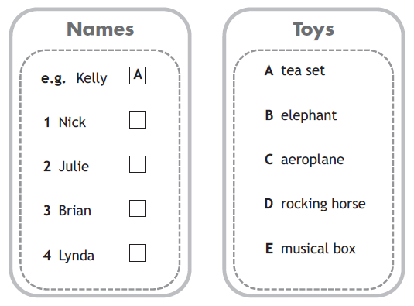

РАЗДЕЛ 2. ЧТЕНИЕ
- Прочитай текст и отметь правильные (v) и неправильные (х) предложения.
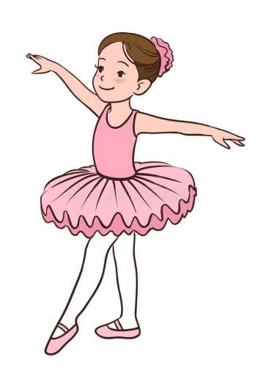
My friend Elisabeth
This is my best friend Elisabeth. She is ten years old. She is from Scotland. She is tall and slim. She’s got long dark hair. She’s got big brown eyes. She can dance and swim, but she can’t play tennis. She likes dancing very much! Her favourite colour is pink. Her favorite food is pizza. She likes dogs. She’s got a small dog. Its name’s Spike. Elisabeth is friendly and nice. She is happy!
- Elisabeth is ten years old.
- Elisabeth is from Russia.
- She’s got long fair hair.
- Her favorite food is pizza.
- She likes cats.

РАЗДЕЛ 3. ЛЕКСИКА И ГРАММАТИКА
- Соотнеси английские слова и их перевод.

- book | _______ | - шоколад
- Music | _______ | - кресло
- father | _______ | - книга
- chocolate | _______ | - папа
- armchair | _______ | - музыка

- Найди и зачеркни лишнее слово в каждом ряду.

- computer, lamp, desk, water.
- mouth, ears, tail, eyes.
- bird, cake, seahorse, rabbit.
- milk, ice cream, apples, boy.
- bedroom, bathroom, kitchen, doll.
- nineteen, seven, thirteen, sixteen.

- Прочитай и соотнеси.
- What’s your name? | _______ | - Yes, I do. Yummy!
- What’s this? | _______ | - My name’s Jenny.
- Do you like pizza? | _______ | - It’s Bob’s.
- Whose is this car? | _______ | - I’m ten.
- How old are you? | _______ | - It’s a teddy.

- Заполни пропуски предложениях . Выбери и обведи нужную букву.

- A spider ________ swim. | - can | - can’t
2) A rabbit ________ got long ears. | - has | - hasn’t
3) ________ are my balls. | - This | - These
4) I’ve got ______ orange. | - a | - an
5) There aren’t _____ chips on the table. | - any | - some

